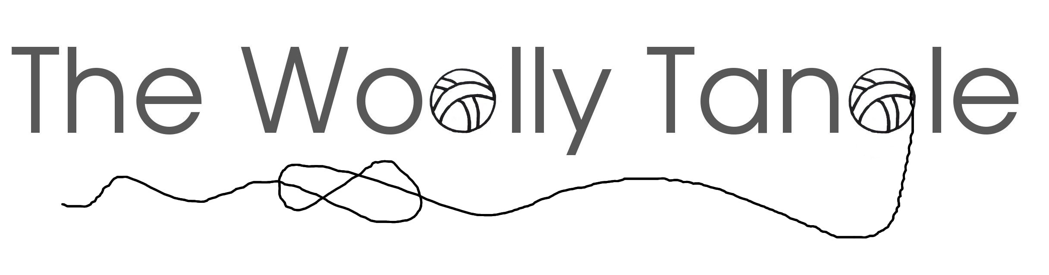

Wholesale information

Yarn Base | Yarn weights available | Meterage per 100g | RRP | Wholesale cost per skein
Silky  50% Superwash merino, 50% Silk | Lace | 800m | £22.00 | £15.50
Silky  50% Superwash merino, 50% Silk | 4ply | 400m | £22.00 | £15.50
Silky  50% Superwash merino, 50% Silk | Sport | 300m | £22.00 | £15.50
Silky  50% Superwash merino, 50% Silk | DK | 212m | £22.00 | £15.50
Tibet  60% superwash merino, 20% Yak, 20% silk | Lace | 800m | £22.00 | £15.50
Tibet  60% superwash merino, 20% Yak, 20% silk | 4ply | 366m | £22.00 | £15.50
Tibet  60% superwash merino, 20% Yak, 20% silk | DK | 212m | £22.00 | £15.50
Supersoft sock  75% superwash superfine merino, 25% nylon high twist | 4ply | 425m | £19.00 | £13.50
 | DK | 225m | £19.00 | £13.50
That  70% Superwash merino, 20% Yak, 10% nylon | 4ply | 400m | £19.00 | £13.50
Wool Cotton  50% superwash merino, 50% cotton | 4ply | 400m | £19.00 | £13.50
Wool Cotton  50% superwash merino, 50% cotton | DK | 212m | £19.00 | £13.50
Egytpian  50% baby alpaca, 25% linen, 25% silk (non superwash) | Lace | 800m | £23.00 | £16.00
 | 4ply | 400m | £23.00 | £16.00
 | DK | 250m | £23.00 | £16.00
Angel  70% baby alpaca, 20% silk, 10% cashmere  (non superwash) | Lace | 800m | £25.00 | £18.00
 | 4ply | 400m | £25.00 | £18.00
 | DK | 225m | £25.00 | £18.00
 | Aran | 166m | £25.00 | £18.00

All skeins, and all prices quoted, in this table are for 100g skeins. If you require minis or 50gs, these can be done as a special order, but please get in touch for availability and prices.

Please be aware that lace, aran or sport are special order & are not found on the website.

Colourways are always available to view on the website. Please be aware that colourways are only guaranteed to look the same as the bases they are shown on. If you want a colourway on a different base to one photographed on the website, please let me know, and I will try and help you with how different it may be. The non superwash bases in particular can look very different to the same colourway placed on a superwash base, and everything looks different if yak is involved!
Order information

Yarn is a 5kg minimum order to qualify for wholesale prices, with multiples of 5 skeins per colourway.

50% of invoice payable upon order, remainder when order is ready to ship.

Payment either through the website or bacs, details will be given with invoice.

Turnaround time will vary depending on size of order & how much is already in stock, I will keep you updated as your order progresses.

Postage is at your cost, and quotes will be gathered as part of the invoice.

RRP's are provided as a guide to the price I sell for and as a guideline only. You are more than welcome to set your own prices, but I do ask that you do not undercut me online, or at any shows we may both be vending at.

Please return completed forms to thewoollytangle@gmail.com, or drop me a message for more information.

Thanks!

Tanya (Chief Tangler)

Registered business address;

Tanya Hardman
2 Bryn Poeth,
Tregarth,
Bangor,
LL57 4PG

www.thewoollytangle.co.uk

thewoollytangle@gmail.com
Order form
Customer name;

Address to be shipped to;

Item order number | Quantity required | Cost per item | Total cost

